How to configure the apache latest version to window 7?

1. Download the apache http server zip file from the below URL.

<http://www.apachehaus.com/cgi-bin/download.plx>

download the version like below screenshot show.

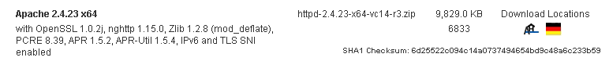

If you cannot find above url, please refer to the below url to get the installation package or zip file

http://httpd.apache.org/docs/current/platform/windows.html#down

1. Unzip the downloaded file to your root directory of your specify disk. Like, D:\Apache24
2. Open the command line window with administrator role
3. CD your directory to your unzip directory. Like, D:\Apache24\bin
4. Input the command like below.

Httpd.exe

It is successful if there is no any error msg and you can check whether it is successful with browser.



<http://127.0.0.1:80>

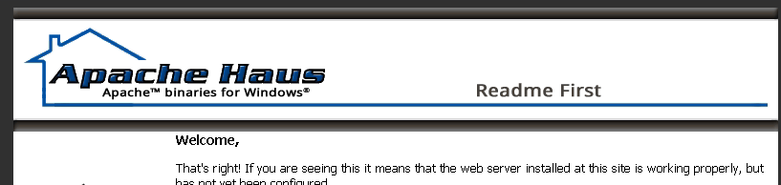

Guider of apache server

Apache comes with a utility called the Apache Service Monitor. With it you can see and manage the state of all installed Apache services on any machine on your network. To be able to manage an Apache service with the monitor, you have to first install the service (either automatically via the installation or manually).

You can install Apache as a Windows NT service as follows from the command prompt at the Apache bin subdirectory:

httpd.exe -k install

If you need to specify the name of the service you want to install, use the following command. You have to do this if you have several different service installations of Apache on your computer. If you specify a name during the install, you have to also specify it during any other -k operation.

httpd.exe -k install -n "MyServiceName"

If you need to have specifically named configuration files for different services, you must use this:

httpd.exe -k install -n "MyServiceName" -f "c:\files\my.conf"

If you use the first command without any special parameters except -k install, the service will be called Apache2.4 and the configuration will be assumed to be conf\httpd.conf.

Removing an Apache service is easy. Just use:

httpd.exe -k uninstall

The specific Apache service to be uninstalled can be specified by using:

httpd.exe -k uninstall -n "MyServiceName"

Normal starting, restarting and shutting down of an Apache service is usually done via the Apache Service Monitor, by using commands like NET START Apache2.4 and NET STOP Apache2.4 or via normal Windows service management. Before starting Apache as a service by any means, you should test the service's configuration file by using:

httpd.exe -n "MyServiceName" -t

You can control an Apache service by its command line switches, too. To start an installed Apache service you'll use this:

httpd.exe -k start -n "MyServiceName"

To stop an Apache service via the command line switches, use this:

httpd.exe -k stop -n "MyServiceName"

or

httpd.exe -k shutdown -n "MyServiceName"

You can also restart a running service and force it to reread its configuration file by using:

httpd.exe -k restart -n "MyServiceName"

Questions & exception while installation or configuration.

1. VCruntime140.dll error

This error will be shown with an alert window. It tells user you are missing the vcruntime140.dll.

Root cause: Apache binaries are built with the original source released by the Apache Software Foundation (unless noted) and have been compiled with Visual Studio 2008 (VC9) or Visual Studio 2012 (VC11) to obtain higher performance and better stability than the binaries built by the Apache Software Foundation

How to fix it?

Download the Visual C++ Redistributable for Visual Studio 2015

URL: <https://www.microsoft.com/en-us/download/confirmation.aspx?id=48145>

Note: if the url is no longer unavailable, please search it with above name then download & install it.

1. OS10013

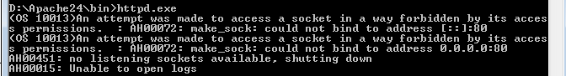

Maybe you will encounter below screenshot show error msg. it is caused by the listen port is using by other software.

How to fix it?

You have two options to fix it.

1). Update your apache listen port to other number

a. Open the http.conf file under the config folder. Like: D:\Apache24\conf

b. search 80 key words in the opened file

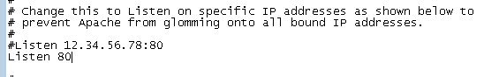

c. Update 80 to 8080, then save it.

d. restart your apache server with httpd.exe command line.

2). Close the software which using the 80 port.

a. Open the command line window

b. Input “netstat -ao”

c. You will find the using software or service like below show.

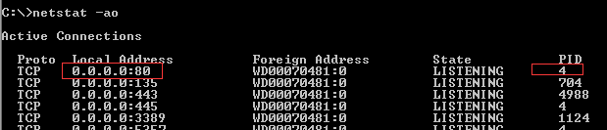

d. Open the Task manage to kill the process with above PID

e. Restart your apache server.